  Place of Residence Geertruidenberg  Age 30  Education  - Premaster Computer Sciences and Engineering (WO)  - Informatics (HBO)  - ICT Beheer (MBO)  Training & Certificates  - EXIN Application Management Foundation with reference to ASL  - OMG-Certified UML Professional Fundamental  - Oracle Certified Professional, Java SE 6 Programmer  - Schakelcursus Wiskunde  - Professional Scrum Master I  - Wiskunde HBO doorstroom  - CCNA 1: Networking Basics  - Microsoft Office Specialist  Spoken Languages  - English  - Dutch | Wim de Kok Java Software Engineer 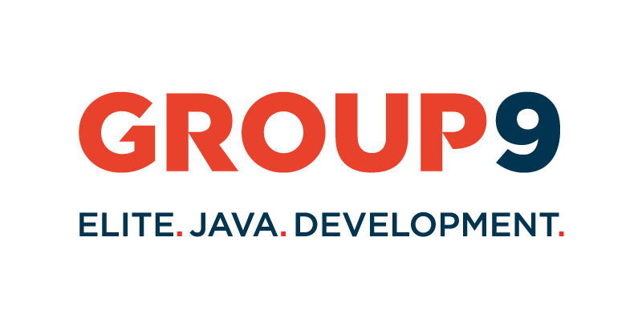

Summary
After graduating, I have gained work experiance as a Software Engineer at Cimsolutions. Cimsolutions is a IT-service provider. I have gained experiance at clients such as: ASM-Europe, Belastingdienst, Douane, Vialis.
After a few years I started working for Simaxx. Simaxx provides a SaaS solution for providing insight into the performance of buildings. Since Simaxx was a start-up, I was able to leave my mark on designing the development process and developing myself in new techniques, such as Kafka & Cassandra.
Some characteristics that describe my personality are that I am social and communicative. I am creative and pragmatic in finding solutions. Improving quality is one of my main goals and I am eager to learn and therefore always looking for opportunities to challenge myself.

Assignments

Simaxx B.V. - Senior Software Engineer
June 2018 - July 2020
The Simaxx platform provides insight in the performance of a building. The building management system (BMS) can be linked. After the BMS is linked the data of the building can be used & analysed. With as goal to reduce cost or improve the comfort of the building.
A few of my task at Simaxx:
• Add functionality to the back-end & analytics module;
• Improve the quality;
• Improve the CI\CD pipeline
• Create a migration plan to migrate to Microsoft Azure;
• Managing a Service partner
• Guiding a internship

Used tools
- Talen: Java, XML, SQL, CQL, JSON, Python, Scala
- Talen: Java, XML, SQL, CQL, JSON, Python, Scala
- Frameworks: Spring, Spring-boot, Quartz
- Testing: JUnit, Mockito, Hamcrest
- Tools: IntelliJ, Maven, SonarQube, Jenkins, Git, BitBucket, Confluence, Jira, Archiva
- Databases: MongoDB, Cassandra, Microsoft SQL Server
- Other: Kafka, Spark, Microsoft SSRS, Zabbix, CentOS

Cimsolutions - Senior Software Engineer
April 2014 - May 2018
Cimsolutions provides ICT consulting services and software development solutions.
The companies that I have been working for in my time at Cimsolutions are:
- Cryo-Save Group
- ASM-Europe
- Belastingdienst (tax authority)
- Vialis
- Belastingdienst - Douane

Tax authority - Customs - Senior Java Software Engineer
August 2017 - May 2018
The Physical Supervision and Travelers team is responsible within customs for handling checks.
The application called PLATO issued work orders to check goods and travelers across the country. All results of the checks are recorded in PLATO.
I was working on expanding the functionalities of PLATO and increasing the quality and maintainability of the application

Used tools
- Talen: Java, Java EE, XML, SQL, JPQL, HTML, CSS
- Talen: Java, Java EE, XML, SQL, JPQL, HTML, CSS
- Frameworks: Wicket, Spring, JDBC, JPA, JMS
- Webservices: JAX-WS
- Test: JUnit, Mockito, Hamcrest, Derby
- Tools: Eclipse, Maven, SonarQube, Jenkins, Git, BitBucket, Jira, Splunk, SoapUI
- ApplicatieServer: WebSphere Application Server
- Omgeving: DB2, mainframe

Vialis - SAAOne - Java Software Engineer
January 2017 - August 2017
Rijkswaterstaat has selected the SAAone consortium for the realization of the A1 / A6 Diemen - Almere Havendreef road extension. The road extension of the A1 / A6 concerns the widening of the route with additional lanes over a distance of 20 km.
The entire route will include a special changeover lane which should be operable from the traffic control center. I was part of the implementation team that creates the software. In addition, I was the first point of contact for test findings and responsible for prioritizing and distributing them to the right people.

Used tools
- Talen: Java, Java EE, XML, HTML, CSS
- Talen: Java, Java EE, XML, HTML, CSS
- Frameworks: JavaFX, Vaadin, Apache Felix, Apache Aries - BluePrint
- Test: Cucumber, JUnit, Mockito, Hamcrest
- Tools: IntelliJ, Maven, SonarQube, Jenkins, Wireshark, Putty
- Omgeving: Apache Karaf

Tax administration - Java Software Engineer
August 2014 - December 2016
Within the Tax authority the Java applications landscape was really diverse. Therefor maintenance of these applications could become more difficult. It cost more time and knowledge than to standardise these applications. To tackle this problem, the Tax Administration has drawn up requirements and guidelines for Java applications. The project “Java Rationalization” was created for this purpose to convert the current applications to these new requirements and guidelines. I have rationalized several applications. In addition, I gave guidance to 2 junior Java developers.

Used tools
- Talen: Java, Java EE, XML, SQL, JPQL, HTML, CSS
- Talen: Java, Java EE, XML, SQL, JPQL, HTML, CSS
- Frameworks: Wicket, Spring, JDBC, JPA
- Webservices: JAX-RPC, JAX-WS
- Test: JUnit, Mockito, Hamcrest, Derby
- Tools: Maven, SonarQube, Hudson, Jenkins,Git, Stash, Jira, Eclipse
- ApplicatieServer: WebSphere Application Server
- Omgeving: DB2, mainframe

ASM-Europe - Java Software Engineer
September 2014 - July 2015

Cryo-Save Group - Php Software Engineer
April 2014 - September 2014

Education

Premaster Computer Sciences and Engineering - Eindhoven University of Technology (WO)
  - August 2012 - April 2014

Informatics - Hogeschool Zeeland (HBO)
  - June 2019 - June 2012

ICT Beheer - ROC Vlissingen (MBO)
  - August 2016 - June 2019

Training & Certificates

EXIN Application Management Foundation with reference to ASL √
  - January 2015

OMG-Certified UML Professional Fundamental √
  - July 2014

Oracle Certified Professional, Java SE 6 Programmer √
  - May 2014

Schakelcursus Wiskunde √
  - August 2012

Professional Scrum Master I √
  - April 2012

Wiskunde HBO doorstroom √
  - July 2010

CCNA 1: Networking Basics √
  - April 2008

Microsoft Office Specialist √
  - June 2007

Spoken Languages

English
  - Professional

Dutch
  - Native

Tools & techniques

Applications
Maven | Advanced
SonarQube | Competent
Jenkins | Competent
IntelliJ | Advanced
Eclipse | Advanced
Git | Advanced
Kafka | Advanced
Cassandra | Competent
Jira | Advanced
Confluence | Advanced

Development Languages
Java | Advanced
SQL | Advanced
Php | Competent

Personal Interests

Smart Home

Hardware

Pc games

Squash

Surfing

Running

